* -: Now we're almost done.
* Let's finish up our form here.
* We got a submit button right now.
* We only log it.
* Now let's add something to our little form here.
* Let's add a horizontal line below it and let's summarize our data maybe in, well, maybe in a new bootstrap row here.
* So let's add a row class and then a column class here.
* A very simple one.
* Let's summarize our data there.
* I'll place the horizontal line between the bootstrap rows and I want to say or output my username here.
* I want to output my mail address, maybe my secret question and my answer to the question as well as my gender.

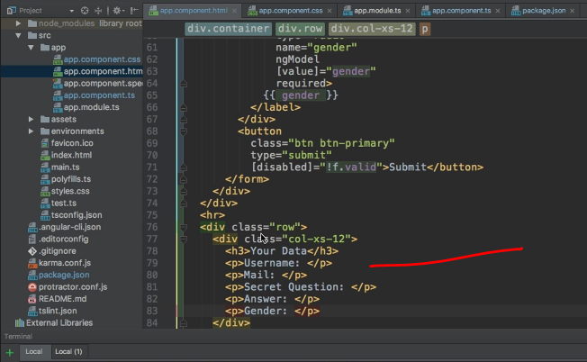

* So just a nice summary.
* I only want to output this once the form has been submitted and then populate with the data of my well submitted form.
* So in the ad app component here I could add a new property named user, maybe which is JavaScript object, which holds a username property.
* Let's set it to an empty string by default, a email property.
* And these names here, of course don't have to match the control names in your form.
* That's a brand new JavaScript object not related to your form directly at least.
* Then here we might also have a secret question which is a string, and then we have the answer, which is a string.
* And finally the gender, which is a string.
* So that's my user object as created by default.
* And when submitting the form, I want to update it.
* So here, then I want to say this user.
* And there I want to access the username, let's say and set this equal to my signup form.
* Access the value of this form.
* And there we know we have a username input field like this, and replicate this.
* Now all the forward, the email, and of course, value of course, was available on the user data grouping though.
* So username and email was in the user data model group kept us in mind.
* So we have to access this model group property first before we can access the final username and email.
* However, the secret question here was available like this.
* We did name the control secret though, so make sure to use secret here when accessing it in the form value.

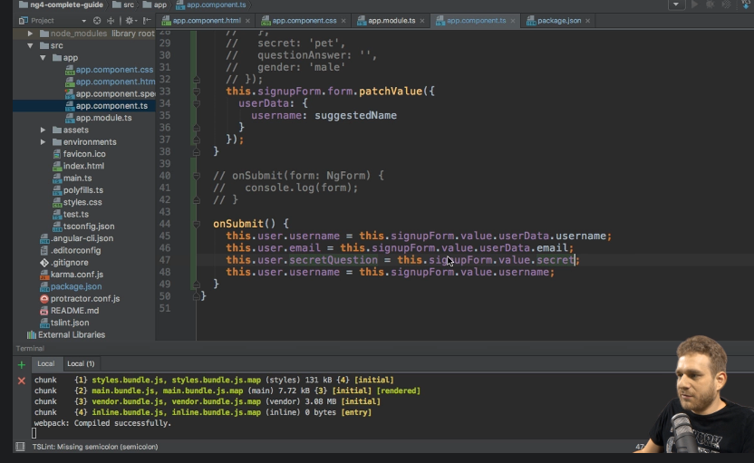

* And the answer.
* Well, let's see which name we gave this.
* We gave it the name question, answer.
* So let's use this when accessing the form.
* And finally, we want to set the user gender equal to what we stored.
* And you sign up form here.
* We did name this control Gender two you can check it down there Gender.
* So with that we now update all that information in our user.
* Maybe we also want to track whether we did submit the forms.
* So we do have a submitted property set to false initially.
* And we set this to true here because, well guess what? We submitted the form.
* And with that, we could place NGF on our row here to check whether the form was submitted and only if it was submitted.
* I want to display this block.
* And here I then want to put user, user name and of course all the other information we gathered, like user email here.
* So let's quickly add all of this here.
* The question would be your first and then we store user secret question.
* Here we have the answer.
* And so on.

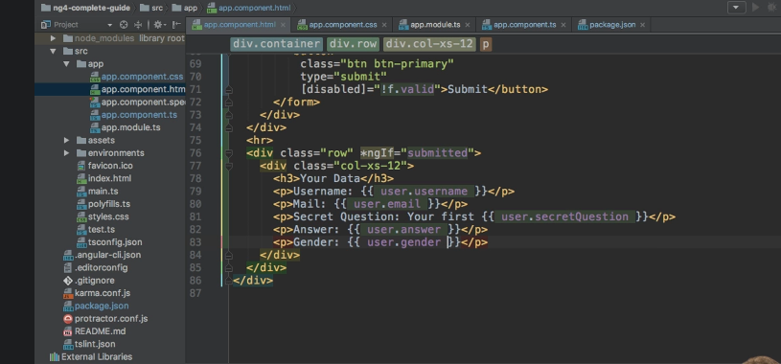

* Of course, structure this in whatever way you want to structured.
* I was just want to show you how you can access your values and use them.
* And with this all in place, now you don't see that section by default.
* But if I enter something here like Anna or let's suggest a username actually my email address, my first pet, which is Nelly and then the gender, I think that surprises you.
* That's not correct though.
* So let's hit submit.
* And now we see the data here at the bottom.
* This is how you can extract the data, how you can use it, how you can add a property, like submit it to make sure you only display certain sections if the form was submitted, and how you in the end use that data.
* One more thing, before we move on to reactive forms, though.